**Advanced Technological Institute – Kurunegala**

www.hndit.com

Sri Lanka Institute of Advanced Technological Education

**IT 4103 – Web Programming**

Higher National Diploma Information Technology -2013, Semester 2

**Tutorial 1 - Java Script**

1. Write a program to display welcome to “Java Script Programming”. Use <h1> headers.
2. Modify above program to display it in red color font.
3. Write a program to give alert “You haven’t permission to access this site”
4. Write a program to input three numbers and display the product of three numbers.
5. Write a script that two integer numbers and determines and outputs HTML text that display whether HTML the first is multiple of second..
6. Write a program to compare (=,<,>,=>,<=) the two numbers entered using prompt , display it in a table.
7. Write a script to take summation of 1 to 100.
8. A online sales company sells three different products where retails prices are:

product1 :Rs.200

product2 :Rs.350

product3 :Rs.400

Write a JavaScript program that read series of product number and quantity sold. Your program should calculate and outputs HTML that displays the total values of all product sols that month. (Hint: use switch structure to define the retail price and use prompt boxes to obtain the product number and quantity sold. User should be able to determine the number of items to be entered use while loop structure.)

1. Write a script to display “good morning” or “good evening” message relevant to current time.
2. Write a program to display day of the current date (Sunday, Monday etc.) using switch structure.

(Hint : var day=new Date().getDay(); day is integer value)

1. Write a program to prompt window when page load to give your name and display “Greeting <<You entered name>> Welcome to my page”. When page unload prompt “Goodbye , Sorry to see you go” (hint write functions called hello( ) and goodbye( ) ).
2. Write a program to show square root of input number.

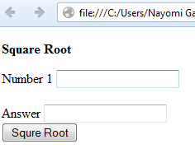

www.hndit.com

1. Write a program to give alert boxes when you clicked submit button if any text boxes are not filled or otherwise thank you message should be displayed. (verify data)

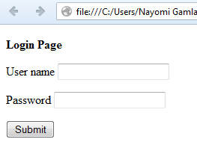

1. Modify above program to check user name and password correct or not. Use your own user name and password.
2. Write a program to give alerts for not filled text boxes one by one in a form. Use your own form.
3. Write a program to multiply two numbers considering following interface.

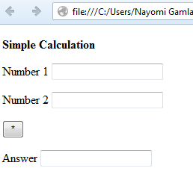

1. Modify above program to make a simple calculator. Data verification should be done ( division zero error etc.)
2. Write a program to display selected language when you click radio button considering following interface.

www.hndit.com

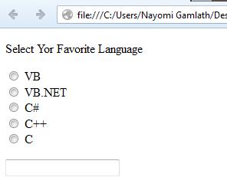

1. Modify above program to display selected language when you click submit button.
2. A sales company pays its salespeople on a commission basis. They receive Rs. 2000 per month fixed salary plus 10% gross sales for that month. Write a script that obtains the gross sales for each employee through an HTML from and determine how many of the salespeople earned salaries of the following range( assume salaries are in integer type)

Rs 100-599

Rs 600-799

Rs 800-999

(Use linear array to solve the problem)

1. Write a script to display entered details of following interface.



www.hndit.com

1. Write a java script program to convert distance.

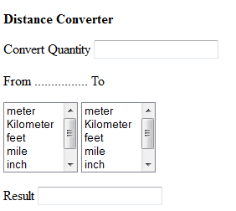

1. Write a program to add five names when click a button called “array test” through prompt window and keep that data in array and display it.